Narratives

Part 1: First Three Paragraphs

- Introduction (Qichuan Xia)

The impact of the pandemic on commercial air travel is a topic of great importance to all parties in the aviation industry in order to adjust business models to the new norm of traffic patterns. To this end, many studies have been done regarding this matter from a business perspective on how airlines responded to the changing market dynamics. However, few studies of comparable depth have been conducted from a humanistic perspective. But there should be more; clearly, the behaviors of passengers have changed a lot, and ignoring them has a worrying result: the number of disruptive passengers reported to the Federal Aviation Administration has increased dramatically since the pandemic, which resulted in delayed/canceled flights and threatened the safety of the traveling public.
Thus, we wish to look at the effect of COVID from the perspective of passengers, the “main character” that is often shrunk to simply numbers by scholars conducting research on this topic. We explored the humanistic justifications behind the business decisions made by airlines and social reasons that lead to the rise of revenge travel, followed by an investigation into the realities of “revenge travel," busting some myths around this popular topic. Our goal is to demonstrate the social causes behind how the interaction between passengers and airlines has changed following the pandemic and the implications this might have on commercial air travel.

- Literature Review (Qichuan Xia)

In current literature on aviation, existing studies present the impact of the pandemic on commercial air passenger traffic in order to shed light on how the commercial aviation industry has changed since the outbreak of COVID-19. Specifically, Jafari showed that classical statistical models employed by the airlines were no longer effective in forecasting demands due to rapidly changing travel restrictions implemented by authorities at different levels. As Javadinasr, Maggasy, and others put it, business travel recovered slowly as people discovered the convenience of working from home and meeting remotely, while leisure travel rebounded almost immediately following the relaxation of lockdown. The recovery was so dramatic that scholars have coined the term "revenge travel." In sum, then, their view is that the commercial aviation industry has changed dramatically since the outbreak of COVID-19.
In recent discussions of commercial aviation, a controversial issue has been whether such changes are temporary or permanent. Although the conservatives like Zhang and Yang on this topic believe travel anxiety due to health concerns outweighs the desire to reconnect to the world; others like Javadinasr maintain that the boom has stabilized and will lead to long-term growth. On the one hand, Garrow, Lurkin, and others argue that legacy carriers are receiving the lion's share of profits. From their perspective, major hub airports won passengers back faster due to stronger demand from a larger population. On the other hand, however, Higgins-Desbiolles and Sun argue that low-cost carriers benefited from “revenge travel” and recovered better than legacy carriers. In the words of Higgins-Desbiolles, one of this view’s main proponents, "The pandemic also sparked greater focus on the value of regional tourism and travel.” According to this view, low-cost airlines focusing on regional flights to secondary airports are getting more attention as travelers seek to bypass hubs for a more direct flight experience. In sum, then, the issue is whether travel anxiety due to health concerns outweighs the desire to reconnect to the world or whether revenge travel will sustain the industry in the long run.
We have mixed feelings. In our view, many more questions remain to be answered. For instance, Javadinasr’s panel study seems to suggest that revenge travel has brought much-needed revenue relief to the industry, but we suspect that the long-term sustainability of this boom has not been tested. In addition, Jarari demonstrated that many assumptions of classical statistical models employed by scholars and analysts no longer met the realities of the post-pandemic. Authors like Javadinasr might object, of course, on the grounds that leisure travel rebounded almost immediately following the relaxation of lockdown. Yet we would argue that we have no answer as to if airlines can generate enough revenue from leisure travelers to replace the lost business clients. Overall, then, we believe there are also new challenges that the industry has not faced before the pandemic, such as tightening environmental regulations and an ever-unstabilizing world, an important point to make given the ongoing changes in the political world of today.

- Significance (Calvin Vo)

Our team’s goal is to bring a humanistic perspective to the T-100 dataset, allowing aviation to be viewed outside of just numbers. Airlines, passenger counts, load factors, and route profitability are all variables used from the database, but our motivation lies within more of the behavioral reasons for why these numbers are what they are during the pandemic, COVID-19. What do these numbers mean exactly? With our dataset, we can trace how the pandemic reshaped not just where planes flew, but why people got on them, allowing us to understand flight was viewed at that time. Our main focus is to use our data to understand the passengers more, giving a perspective that remains outside of business analytics.
Our motivation opens up many questions that give us a better understanding of what we want to tackle for this project. Why did leisure travel rebound immediately while business travel struggled for years, and what does that gap say about the people who were experiencing the pandemic? Since traveling has been a huge topic during and even after the pandemic, much of the data shows changes before and after COVID. Even certain locations for airports succeeded while others struggled. Why did airports in LA struggle while other areas succeeded? Outside of logistics, this gives us evidence of how much people shifted their thoughts about traveling during that time, especially for the environment that they were from.
However, the recovery of travel isn’t as uniform as it seems. With unexpected patterns, this suggests where people are interested in traveling to after the pandemic. The recovery wasn’t as smooth as it seems, as rates were slowly recovering from how much they lost during the pandemic.
With this project, we hope to push beyond a narrative that analyzes air traffic in terms of numbers. By understanding how revenge travel was applied to this situation, we hope to understand who is flying, why they choose to fly, and how these behavioral choices ultimately led to how airlines plan their routes from before to after the pandemic. With our study, we believe this will open up new ambitions in this field of interest.

Part 2: 5-6 Data Visualizations

1.sarah min
- Is there a correlation in the World Happiness Report's social support and institutional trust measures that explains compliance-driven travel collapse? I.e., did countries where people trust their government see sharper voluntary drops in flying (people obeyed advisories) versus mandate-driven drops elsewhere?
- Did COVID permanently change the dates people fly? Day-of-week and time-of-day departure distributions before and after, such as business travel shifts and hybrid/remote schedules creating new leisure travel patterns Sunday-Wednesday

Research Question 1: How did the average number of passengers per departure change on U.S.
commercial aviation flying fewer between 2019 and 2025?
Chart 1 (bar chart):
A bar chart fits this question because the data measures a single quantitative measure, average
passengers per departure, calculated from the BTS T-100 Segment data as total passengers divided by
total departures performed. It is compared across discrete, ordered categories (years), with a second
nominal category (domestic versus international service) distinguished by color.
Because every bar starts at zero each bar's height directly corresponds to its value and the reader can
directly compare any two years or either travel type at a glance, which line charts or area charts would
not make as immediately evident for only seven time points. The chart shows each year from 2019
through 2025 on the horizontal axis, with paired bars for domestic and international flights. Domestic
flights averaged 95 passengers per departure in 2019, dropped to 65 in the collapse year of 2020, and
then climbed past their pre-pandemic level to roughly 106 by 2023, settling near 101 in 2025.
International flights followed the same trajectory from 150 down to 110 and back up to about 158.
This pattern is significant because when compared to total departures, which remained below 2019
levels even as total passengers surpassed them, it indicates airlines replaced the pandemic-era schedule
by concentrating recovering demand onto fewer, larger, fuller aircraft.Consequently, the chart provides a starting point for the analyst, to look deeper into fewer flight choices
for travelers, potentially reduced service to smaller cities, but also fewer takeoﬀ-and-landing cycles per
passenger carried, the most fuel-intensive phase of flight, suggesting the post-COVID system may be
more eﬃcient even as it is less convenient.

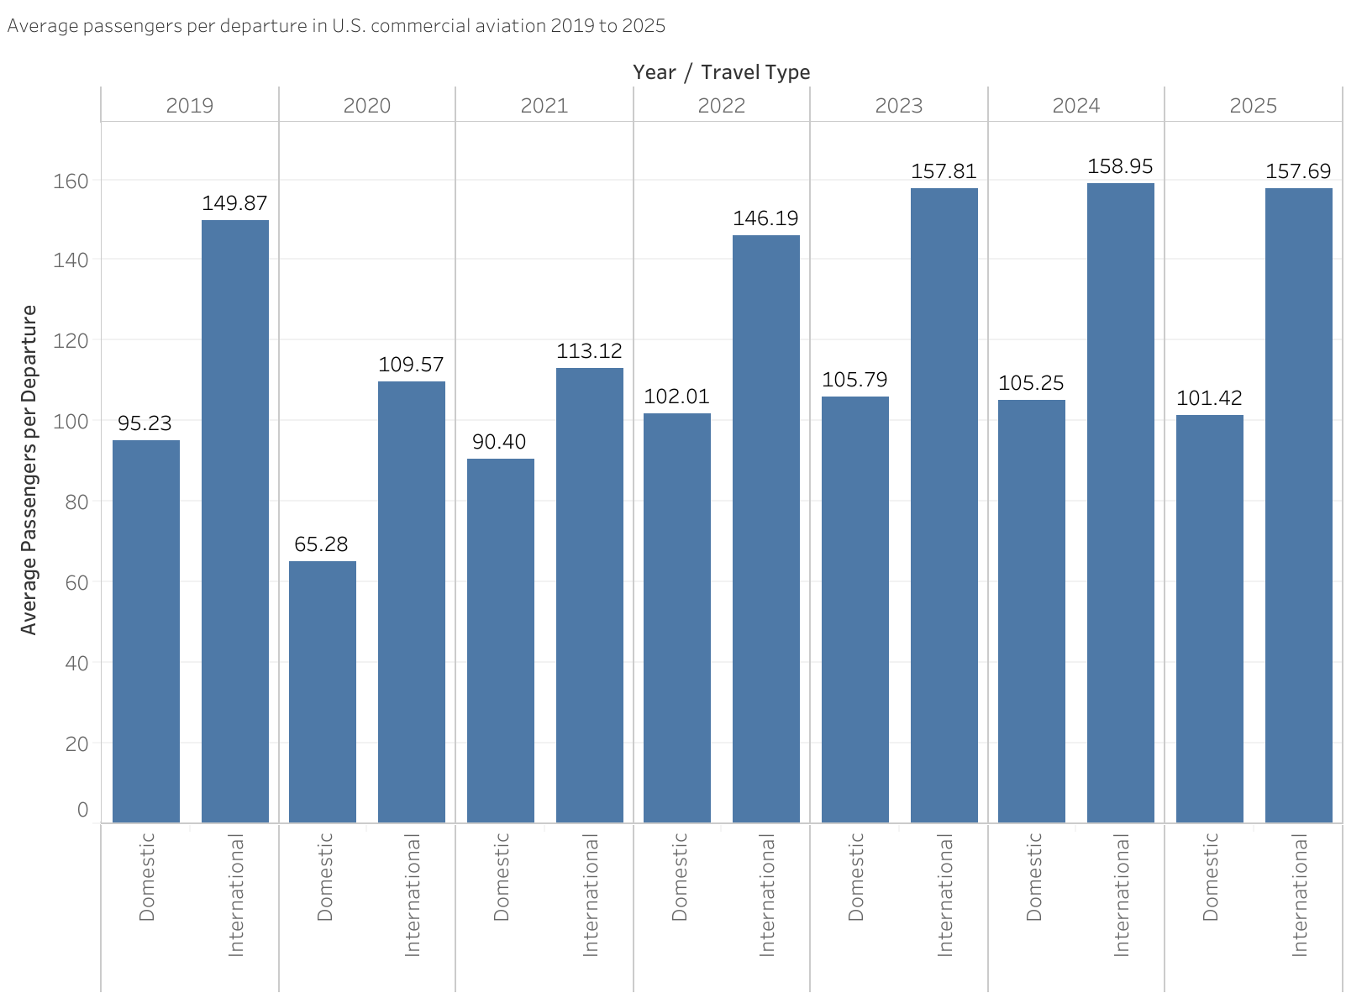

Research Question 2: Was national happiness during the COVID-19 pandemic associated with the
severity of each country's collapse in air travel, and with how fully its air travel recovered afterward?
Chart 2 (scatter plot):
A scatter plot fits this question because it asks about a relationship between two continuous variables
measured across many units, rather than a change within one unit over time like the previous research
question. Each country contributes one point whose position encodes both its 2020 Gallup World Poll
life-evaluation score (surveyed during the pandemic) and the percentage change in air passengers
carried, with two stacked panels sharing the happiness axis to show the same relationship at two
horizons: the collapse (2019→2020) and the recovery (2019→2023). A fitted trend line summarizes the
association.
The chart shows a weak negative relationship with r ≈ −0.18 between happiness and collapse in air
travel. Contrary to the intuition that unhappy populations grounded themselves, the world's happiest
countries during COVID, including Finland (7.9), Iceland, Switzerland, and the Netherlands, suﬀeredamong the deepest collapses, all losing 68–81% of their passengers, while several lower-scoring
countries such as China (−37%) declined far less.
One possible explanation is not happiness itself but what kind of flying each country depends on.
The happiest countries are wealthy and internationally connected, and border-dependent international
travel collapsed hardest and recovered slowest, while large domestic markets rebounded quickly.
However, without further analysis, surveys, data collection, or investigation, the r-value and scatterplot
only implies correlation and the exact cause is hypothetical.
Because happiness and travel were measured in the same period, both shaped by the pandemic itself,
this chart can establish association only, not causation.
Furthermore, a gap important to note in the data is that the World Bank attributes passengers to the
country where the airline is registered, not where people fly, which may lead to inaccurate location
reports. Furthermore, I excluded Zambia and the Dominican Republic from the recovery panel as
artifacts of that method because they had no registered carriers prior to COVID. This means their
"growth" post-COVID19 reflects newly registered carriers on near-zero 2019 baselines.

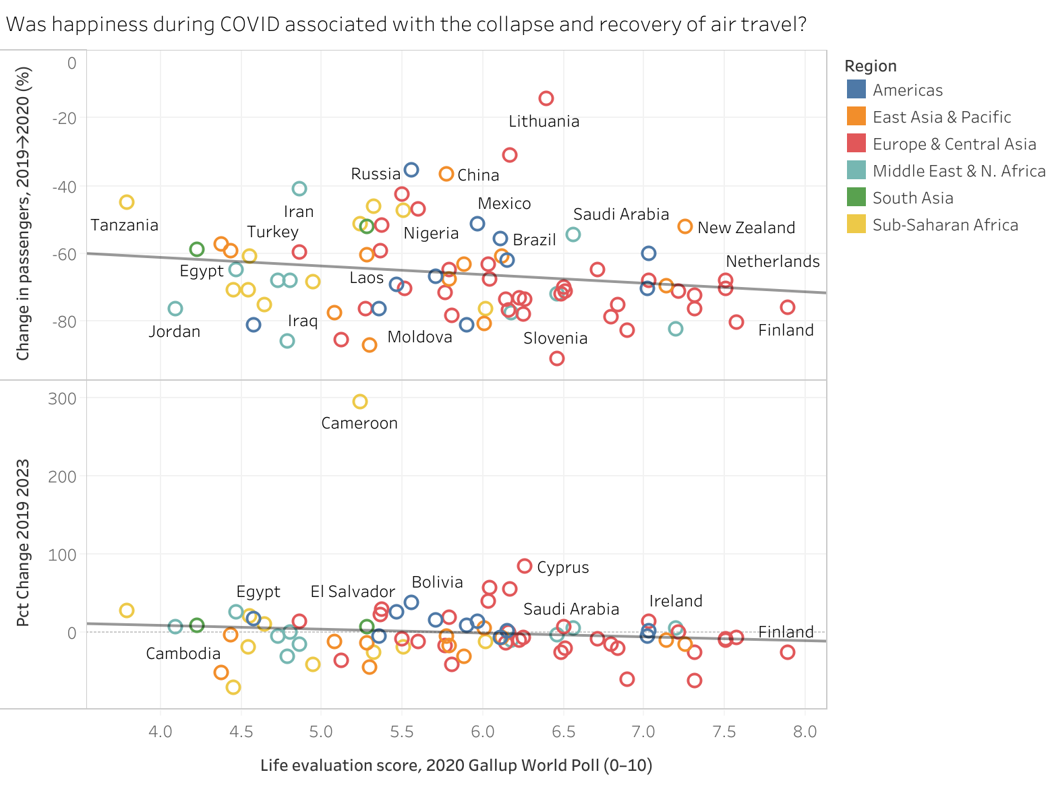

2. Qichuan Xia

How did the numbers of total monthly air passenger traffic in the top 10 most populated U.S. metro areas change along with the development and demise of COVID-19?

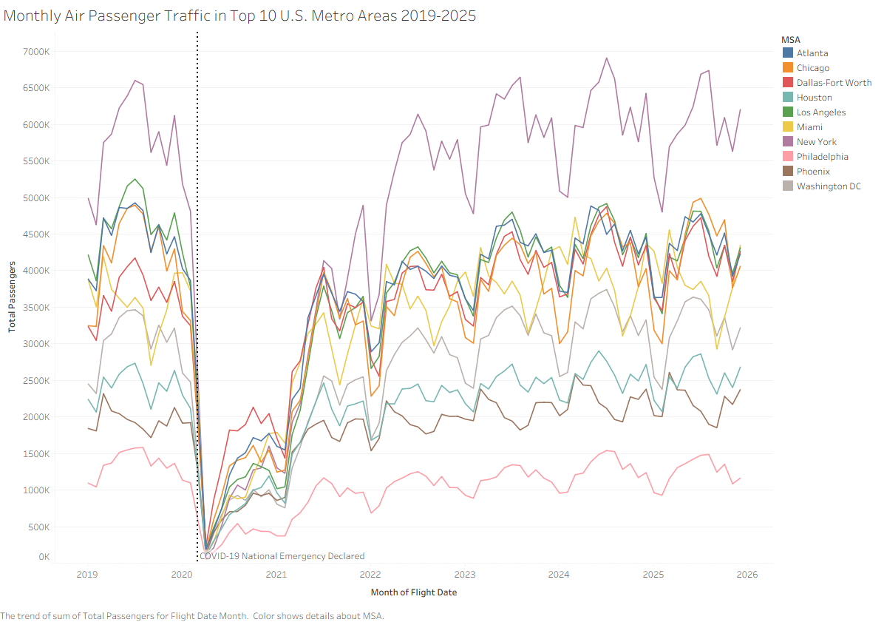

Since we need to display monthly air passenger traffic for all 10 MSAs, this is a perfect scenario to use the line chart to visualize the changes over time. The horizontal axis is the month of the flight, for which we interpolate the monthly data points to make a continuous line. The vertical axis is the total passenger numbers in thousands. The horizontal lines are color-coded with each color representing one of the top 10 most populated MSAs. There is also a vertical reference line in March 2020 where COVID-19 was declared a national emergency. During “normal” years, the monthly air passenger traffic numbers exhibit a cyclic pattern with a high season in summer and low season in winter. All 10 lines saw a dramatic drop of passenger numbers in 2020 before recovering in 2021; the yearly cyclic trend was resumed in 2022 with numbers below the 2019 baseline. The baseline was subsequently achieved in 2024 for most MSAs.
The chart clearly demonstrates that COVID-19 severely impacted air passenger traffic in 2020, with a historical low passenger count recorded in April 2020 for all MSAs. While New York normally leads in passenger traffic, during the second half of 2020, Dallas-Fort Worth led. Given that Texas is a conservative state with fewer travel restrictions than liberal states like New York, it is possible that a correlation exists. While most MSAs have recovered from COVID-19 with peak passenger numbers exceeding the 2019 baseline in 2024 or 2025, Los Angeles has not recovered and lost its second spot for most of 2025, an interesting observation given that it is still the second largest MSA by a wide margin. Finally, for every winter since 2022, Miami briefly popped out as the second busiest airport in terms of passenger traffic while staying below the other MSAs for the rest of the year, suggesting that winter activity in the U.S. is heavily concentrated in southern Florida.

3. Kyaw

4. Wenkang Huang

Was the post-COVID recovery in U.S. passenger air travel driven primarily by the restoration of nonstop routes or by increased passenger traffic on the routes that remained？

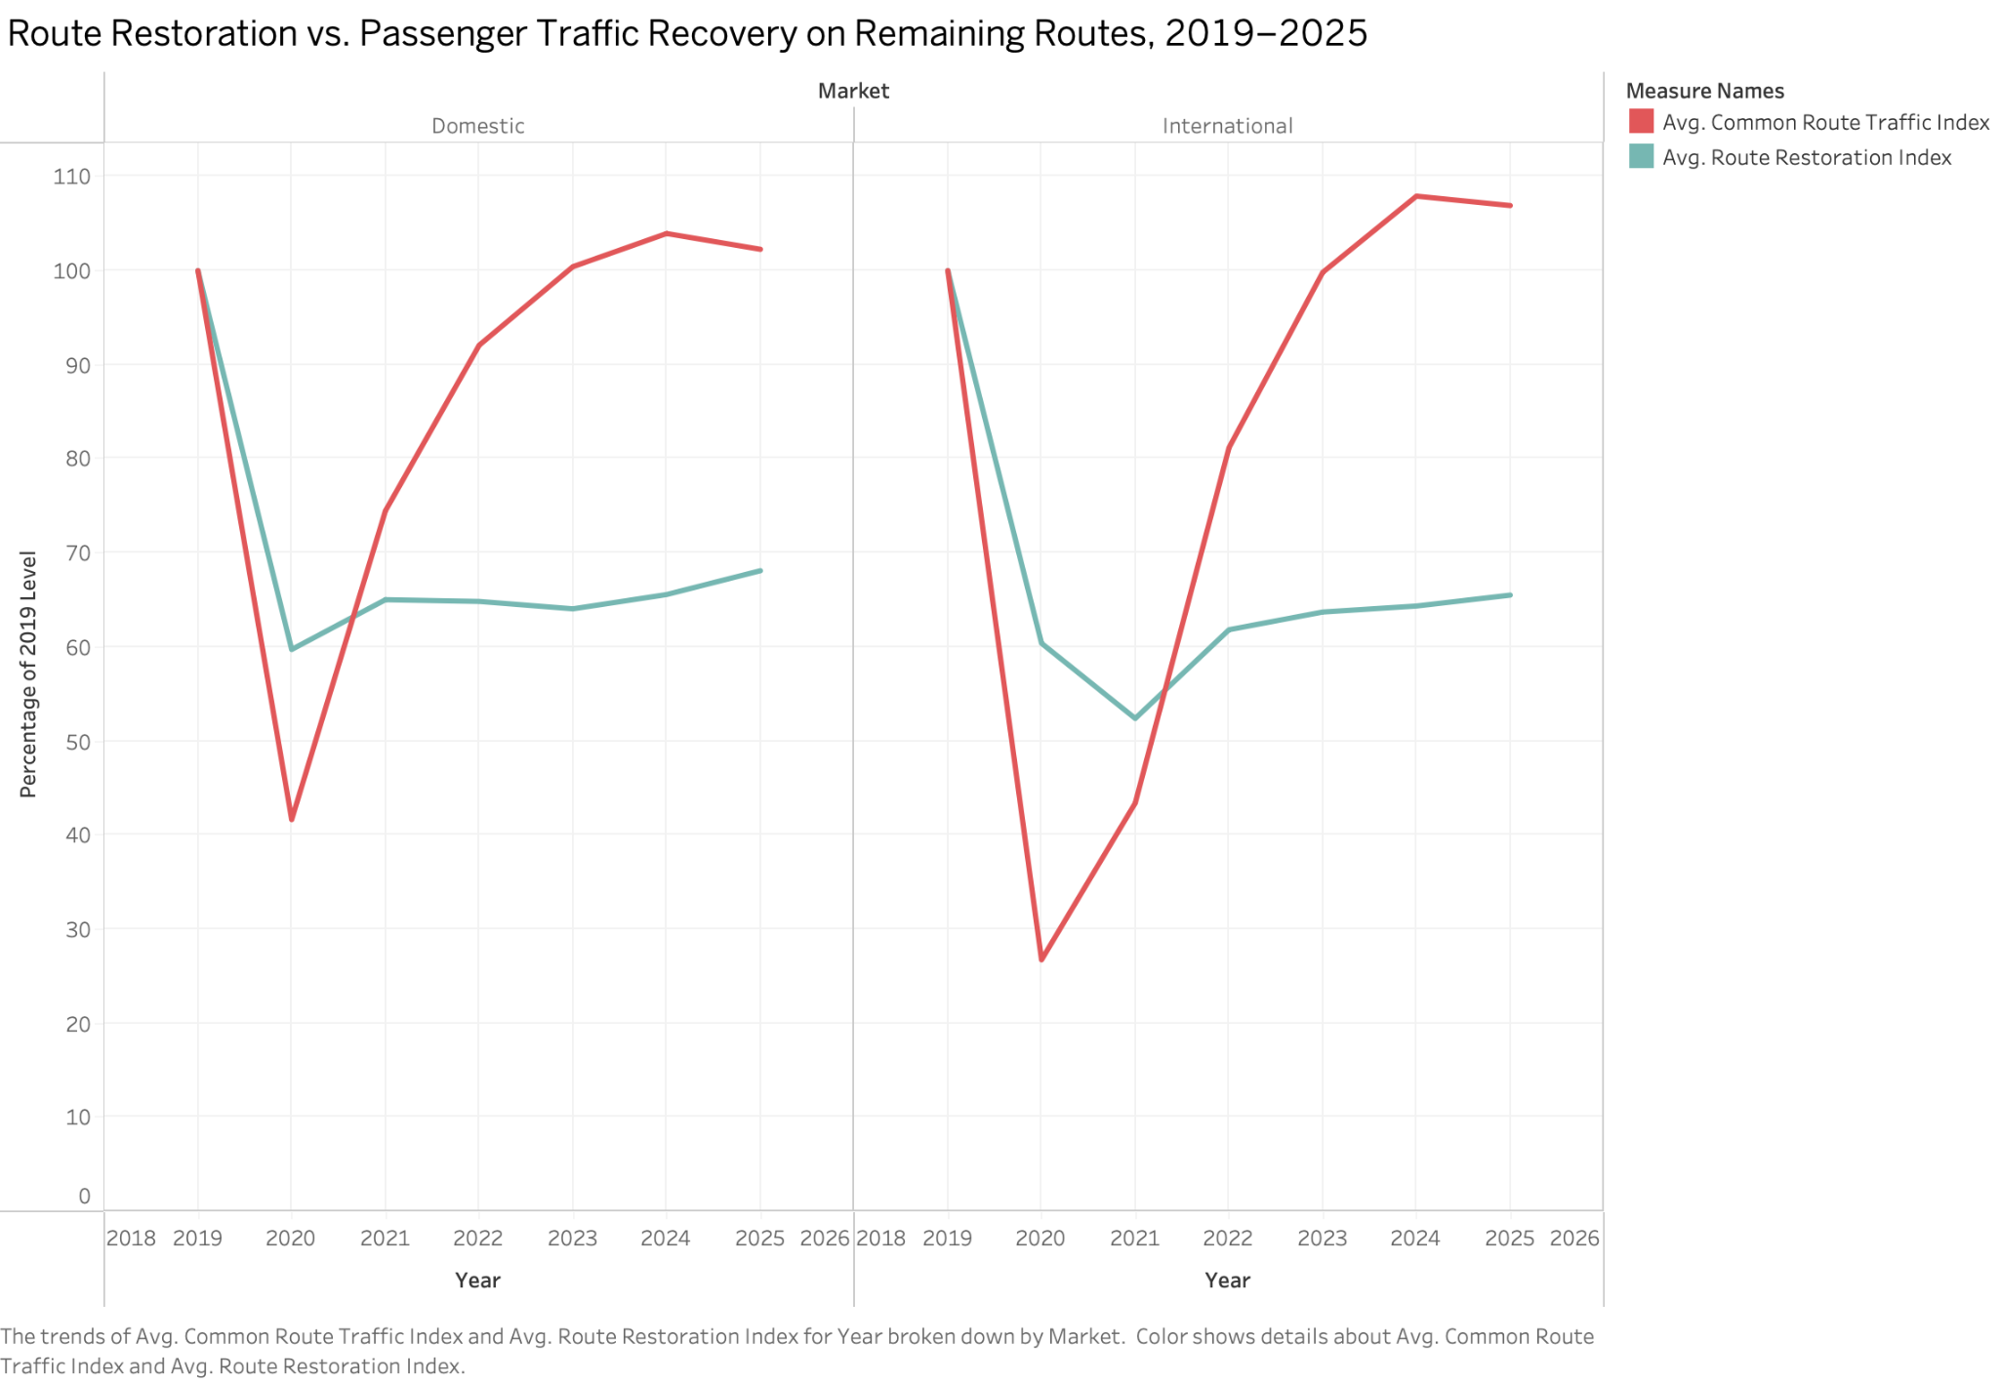

The line graph can be considered suitable for answering the second research question since it demonstrates the continuous changes in two measures of recovery and allows easily comparing whether the dynamics of recovery of passenger traffic and the route network were similar or different. Passenger traffic on the retained routes (red line) starts from 100 in 2019 and goes down significantly faster than route restoration (teal line) in 2020 and reaches 42% (domestic market) and 27% (international market), while the number of active routes from 2019 in both markets remains at about 60%. Starting from 2020, the passenger traffic grows very fast and finally even surpasses its pre-COVID-19 levels. By 2025, passenger traffic on retained routes becomes about 102.3% in the domestic market and 106.9% in the international one. On the contrary, route restoration remains much lower: about 68.1% and 65.5%, respectively. Therefore, one can conclude that the passenger recovery after the pandemic was connected not with the full restoration of the route network, but with the increase of traffic concentration on the retained routes. Nevertheless, it cannot be assumed that the overall size of the route network got smaller, because airlines may discontinue some routes and introduce new ones. The line chart shows significant network reconfiguration. It generates new research questions such as what airports and regions lost connections, where new routes emerged, did airlines concentrate flights at hubs, and whether the growth of traffic on retained routes is connected with the increase of number of flights, larger capacity of aircrafts, or load factor.

5. Calvin Vo (may delete later if doesn’t apply well to our narrative)
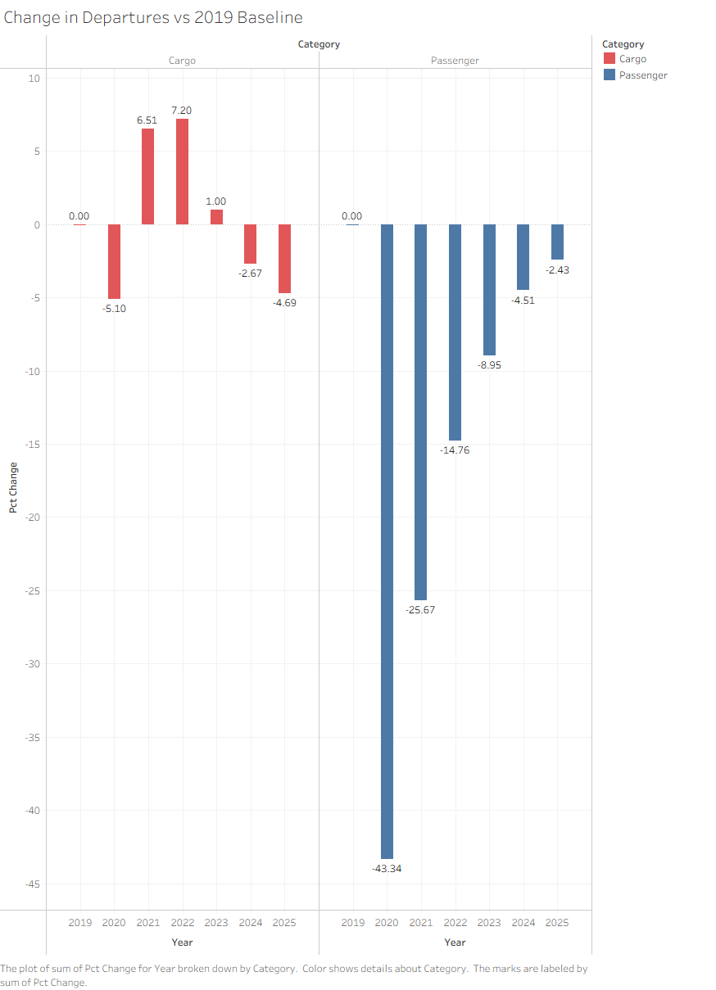
The bar chart analyzes the comparison between air cargo and passenger departures every year against the 2019 baseline statistics. This reveals that both groups responded differently during the COVID-19 pandemic. Cargo departures experienced a 5% decrease in cargo traffic, while passenger departures experienced around a 43% decrease in traffic in 2020. The collapse of passenger departures reflects heavily on the shutdown of most travel during the lockdown, as many individuals were mandated to quarantine at home. In addition, most countries closed their borders, shutting down international travel. The decrease in cargo traffic is roughly eight times smaller than the decrease in passenger departures in 2020. This suggests that most demands were far less sensitive to the effects of COVID or travel restrictions and continued to proceed in cargo deposits regardless of the restrictions that were placed on traveling. By 2021, cargo was able to exceed the 2019 baseline at a rate of a 6% increase, while passenger traffic was still at a collapsed rate but improving from 2020, with roughly a 20% increase. After the effects of COVID, passenger rates began to gradually increase but still at a reduced rate compared to their 2019 baseline, while cargo rates began to settle down, indicating that travel restrictions began to lift and cargo demands began to decrease. Although passengers were the most affected during COVID, they also showed great recovery after the pandemic. In addition, passengers also indicated that it has a higher relationship to the COVID outbreak than cargo did, whether it was its collapse or its recovery.

Part 3: 1-2 Maps

Qichuan Xia
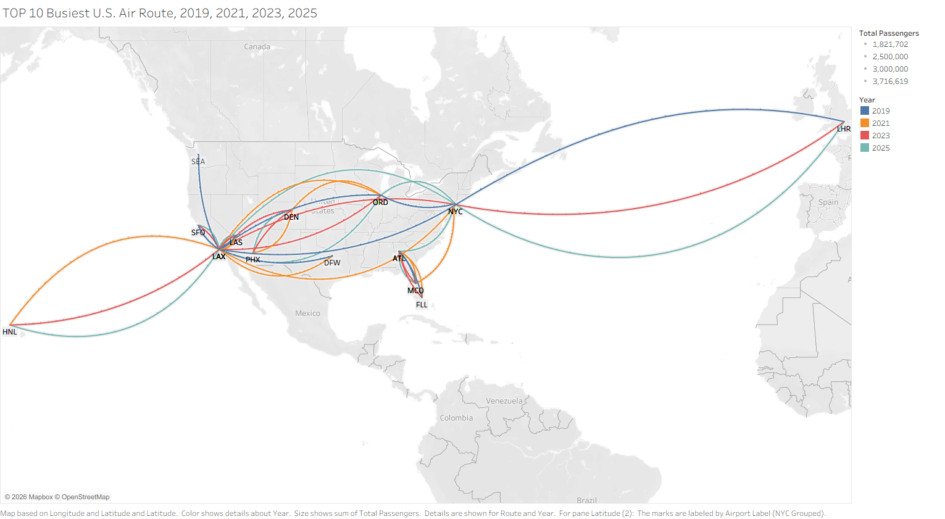
The map was created from our primary dataset about air traffic (T-100), which is used to calculate the busiest air routes, together with airport spatial data from OpenFlights, which is used to render flight paths. These datasets were joined together using R in RStudio, where I also created the curvature using the curvature option in the tibble() function. I used a Bezier curve for aesthetic purposes and also for preventing overlapping if the same route pair appeared on the list of 10 busiest routes for multiple years. The four years of observation, 2019, 2021, 2023, and 2025, were coded by color. Individual airports are used as the basis to calculate total passenger numbers. However, since all three major airports in the New York metropolitan area (EWR, LGA, and JFK) appeared on the list, and displaying labels for all of them would create overlap, the codes for these airports were combined as a generic NYC. The map is a direct visualization of how COVID impacted the passenger flow, which serves as the empirical evidence for our research project.
It is apparent that east-west travel to and from major hub airports dominated the list. Los Angeles (LAX) is noted as the most significant node on this map where the most number of routes originated. However, this observation actually suggests a problem with the airport system in Los Angeles. Compared to New York, which spreads the load more evenly across its three major airports, Los Angeles concentrates all of its traffic at LAX instead of spreading to Long Beach or Ontario. This has resulted in congestion on both the land and air sides at LAX, while the airports in Long Beach and Ontario are noticeably underutilized. Moving on to the Southeast, a self-contained loop consists of the routes from Atlanta (ATL) to Orlando (MCO) and Fort Lauderdale (FLL) is an indication of successful, massive hub operation by Delta Air Lines at ATL, the busiest airport in the world in terms of passenger traffic. The local demand is nowhere near sufficient to put these two city pairs on the list, yet, through the hub-and-spoke model, Delta funneled passengers from all over the country and “created” demand on these two routes.
This map echoes the panel study done by Javadinasr and other researchers (2022). The reduction in business travel caused by the pandemic is evident in Seattle (SEA), a major corporate hub that draws plenty of business traffic. While one route relating to SEA made it to the top 10 list in 2019, none appeared in the subsequent years, suggesting decreasing business traffic. The rise of domestic tourism, as argued by Higgins-Desbiolles (2022), is explained by the appearance of Honolulu (HNL) on the list since 2021. While the LAX-HNL route did not make the list in 2019, it did for all of 2021, 2023, and 2025, suggesting a potentially permanent shift to domestic tourism. The sudden collapse and subsequent recovery of international travel, as documented by Gao (2022), is represented by the New York (NYC) - London (LHR) route disappearing from the list in 2021 but remaining on the list for all other years: 2019, 2023, and 2025. This is also notably the only international route on our list, suggesting a deep relationship between the United States and the United Kingdom.

Sarah Min
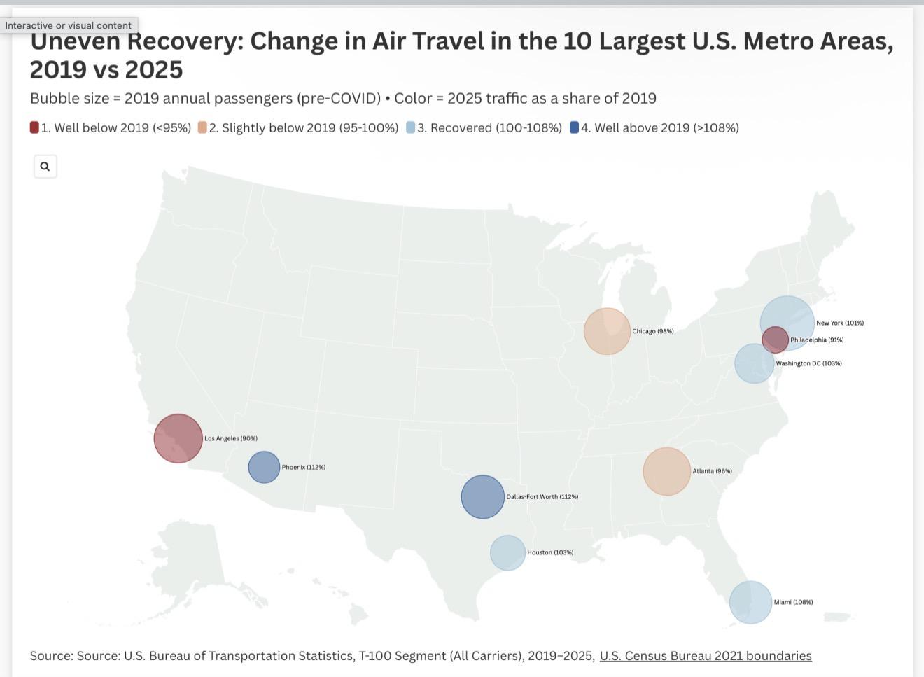
I created this map in Flourish using its US states projection template.
I completed data preprocessing by first aggregating our team's BTS T-100 Segment data
(2019–2025) into annual passenger totals for the ten largest U.S. metropolitan areas. I chose a
proportional symbol map for the purpose of encoding two variables at once: bubble size shows
each metro's pre-pandemic (2019) passenger volume, and a classed red-to-blue color scheme
shows how fully each metro's traffic had recovered by 2025 relative to its 2019 baseline. This
map directly addresses our project's central question of how COVID-19 affected commercial air
travel in the largest U.S. metropolitan areas and whether the recovery was geographically even.

The map reveals that the pandemic recovery was geographically uneven, with a clear advantage
surrounding the Sun Belt. Namely, Dallas–Fort Worth (112%), Phoenix (112%), and Miami
(108%) all exceeded their 2019 passenger volumes by 2025, while Los Angeles (90%) and
Philadelphia (91%) still had not fully recovered. New York, which suffered the steepest 2020
collapse of any metro (a 71% drop from baseline), only barely returned to its pre-pandemic
baseline at 101%.Spatially, the blue "recovered" bubbles concentrate in the South and Southwest.
This pattern suggests that recovery tracked broader population and economic migration toward
the South and Southwest, which connects to our data critique, where we proposed comparing
airline network changes against the "Southward Expansion" of the U.S. population. The map
offers a first piece of evidence that post-COVID air traffic did follow that southward shift. rather
than simply reflecting each metro's original size.
The lag in metros like Los Angeles may also reflect durable shifts to remote work and reduced
business and international travel, which disproportionately hit metros dependent on those
segment hardest. These disparities are significant for our project because they suggest that
COVID-19 redistributed air travel patterns, reshaping which regions people travel to and from,
and which metro areas now anchor the air travel network.

This uneven geography is consistent with the claims of with Gao (2022), who clustered 118 U.S.
hub airports by their pandemic recovery trajectories and tested how geographic location shaped
the recovery of air travel demand, confirming that recovery varied substantially across regions
rather than proceeding uniformly. The lag in large coastal metros is also consistent withJavadinasr et al. (2022), whose national panel survey found that pandemic-era increases in working from home were expected to persist, with implications for reduced business air travel.

Namely, 48% of the respondents anticipate having the option to WFH after the pandemic, which
indicates an approximately 30% increase compared to the pre-pandemic period. In the
post-pandemic period, auto and transit commuters are expected to be 9% and 31% less than
pre-pandemic, respectively, with an expected rise in hybrid work and grocery online shopping.
Interestingly, 41% of pre-covid business travelers expect to have fewer flights (after the
pandemic) while only 8% anticipate more, compared to the pre-pandemic, which plausibly
provide context to reductions in air travel for business travel-heavy hubs, such as Los Angeles,
New York, and Philadelphia.

Gao, Yi. 2022. "Benchmarking the Recovery of Air Travel Demands for US Airports during the
COVID-19 Pandemic." Transportation Research Interdisciplinary Perspectives 13: 100570.
https://doi.org/10.1016/j.trip.2022.100570.
Javadinasr, Mohammad, Tassio Maggasy, Mahmoud Mohammadi, Kouros Mohammadian,
Ehsan Rahimi, Deborah Salon, and Sybil Derrible. 2022. "The Long-Term Effects of COVID-19
on Travel Behavior in the United States." Transportation Research Part F: Traffic Psychology
and Behaviour 90: 466–484. https://doi.org/10.1016/j.trf.2022.09.019.

Part 4: Other Photographs/Illustrations

Part 5: Conclusion

About

Sources

The main source for our project is the T 100 Segment data provided by the United States Bureau of Transportation Statistics. This dataset contains information on flights at the segment level and such information as year, month, carrier, origin airport, destination airport, flight distance, departures performed, available seats and passenger totals. To see how air travel was affected by the COVID 19 pandemic and to study how the recovery from the pandemic proceeds differently among various aspects of the airlines' network, we used data for years 2019 through 2025. Year 2019 was chosen as the baseline for our project since it is the last year without any pandemic-related disruptions in air travel. In this way, using the following years for comparison, we could study the first drop in 2020 and assess the degree of recovery until 2025. Unlike national passenger totals, our interest in recovery process required looking into the route and distance information to see whether the recovery happened uniformly between different kinds of air travel.

This dataset is suitable for our project due to the opportunity to investigate passenger activity from several viewpoints. Flight distance helped us to compare short-, medium- and long-distance travel. Origin and destination gave us information on the routes. Passenger totals for each year showed us the recovery process over time. Altogether, these variables allowed us to ask our questions on passenger recovery and the restoration of the airline network.

Secondary sources from the annotated bibliography help to provide historical, political, economic and social background for numerical patterns presented in the visualizations. It is easy to see passenger decline or recovery with the airline data, but secondary sources give us an explanation why these patterns occurred: in relation to public health restrictions, changes in behavior, economic uncertainty, reopening policies and the general significance of mobility.

The project timeline was constructed based on reliable secondary sources providing information on key pandemic events and its influence on travel. These events were arranged along with the aviation data to give the reader an opportunity to understand passenger activities within the framework of historical events.

In her article Johanna Drucker states that "the source level of the project refers not only to materials gathered by the researcher, but also to the decisions made in selecting and organizing them".¹ Choosing the T 100 dataset, concentrating on the years 2019 through 2025, setting 2019 as the baseline and arranging the records according to distance, passengers and routes were the decisions that affected the questions we could ask and interpret our subject.

Processing

Data was processed and analyzed in R. We chose to use R because the program would allow the team to combine multi-year airline data sets, produce summaries, compare categories and produce visualizations in a cohesive analytical process. First, the yearly data sets were loaded and combined so that we could analyze the change across the whole period from 2019 through 2025. After that, the variables relevant to our research questions were selected. These include year, month, origin, destination, distance, passengers and other indicators of airline activity. As our raw dataset consists of flight segments' data, we needed to organize the information in such way that it could help us to answer our humanities questions. Each record was organized in categories for the comparison across years, distances and routes.

For the distance analysis, flights were split into three groups. Flights under 500 miles are considered as short distance flights. Flights from 500 through 1,499 miles are medium distance flights. Flights equal or longer than 1,500 miles are considered as long distance flights. This grouping helped us to see whether the different forms of air travel recovered in a similar manner. Without grouping the distance variable, there will be too many different distances to compare. With these three categories, it became easier to see general differences between the shorter and longer trips.

Total passenger numbers were calculated for each distance category. Then we compared the total numbers from each year with the total numbers of 2019 year. The passenger recovery index was calculated as:

Passenger Recovery Index = Passenger Total in the Selected Year ÷ Passenger Total in 2019 × 100

Index value of 100 means that the passenger activity is equal to the 2019 year's activity. Below 100 value means that activity level is still below baseline, while value greater than 100 means that activity is higher than in 2019 year. Calculation of index rather than just passenger totals made comparisons of the three distance categories easier. As short, medium and long distance flights have started with different number of passengers in 2019 year, their conversion to the same baseline made it easier to see the relative recovery rate. Otherwise, the largest category would have dominated comparison due to its larger passenger number regardless of actual recovery rate.

Route analysis involved different processing procedure. Origin and destination airports served as a base to identify the connections between places. The comparison between the routes of 2019 and of the following years helped us to understand the extent of restoration of airline network. Also, we needed to distinguish the recovery of routes and passenger traffic on the remaining routes. These are two different forms of recovery. An airline network could serve a lot of passengers while maintaining smaller number of routes as the traffic is concentrated on a few connections. The Route Restoration Index was calculated as the proportion of routes from 2019 year which were active in a selected year. The Common Route Traffic Index was calculated as the passenger activity on routes which existed in both 2019 and the selected years. Distinguishing between these two indexes helped the project to find out whether the recovery was achieved due to the restoration of connections or due to the increased activity on existing routes.

These processed summaries were then used for producing the charts and the map in R. The processing of data was not just an attempt to clean the data set. It was a transformation of millions of individual flight records into the evidence which could help us to answer our research questions. Drucker claims that computational processing forces the researcher to make categories, relations and analytical constructs.² Our distance categories, recovery index, route comparison and 2019 baseline were all constructed analytical choices. These choices made the data set comprehensible, but also made patterns which will be found in our visualizations possible. That is why, besides calculating the values, we documented each of our calculations to explain why they are suitable for our project.

Presentation

The project is designed as a web based mini site including written text, visualizations, maps, timelines, illustrations, annotated bibliography, data critique, and project and author information. The use of this layout enables moving back and forth between numerical evidence, geographic patterns, historical background, and written interpretation. Visualizations are embedded in the text. They are not shown as stand alone graphics with no explanations. Each visualization answers a specific humanities question and accompanying text informs about observations a reader is expected to make, relation to the research topic, and significance of the results. The distance recovery visualizations include short, medium, and long distance passenger activity for 2019 through 2025. Using 2019 as an index with a value of 100 provides a common reference point for all three categories. The presence of a reference line at 100 makes it easy for readers to determine whether any of the categories stayed below its previous value, reached it again, or went above it. These visualizations reveal that the plunge of air travel in 2020 was serious, yet the recovery of the different distance categories occurred differently. Some categories regained their passenger numbers faster than others. The use of all three categories side by side in the same charts shows that the term “air travel recovery” refers to different trends rather than to one uniform process in the country.

Route visualizations pose a different research question. These charts compare restoration of the route network and passengers on the routes that remained open. The results show that passengers on the routes that remained open recovered more than the total number of routes. In other words, the increase in passenger totals does not imply a full recovery of geographical connections. This distinction is one of the key insights of the project. While a national passenger total may indicate recovery of the airline industry, the route level data may show that some connections are missing. Therefore, the recovery can happen as a consequence of focusing on the routes rather than restoring the whole network.

The map presents the geographic aspect of the problem that cannot be told using passenger totals. Readers have an opportunity to understand what areas have the most route activity and how various locations are interconnected. This map also helps explain why route recovery is important as a humanities question. Loss of a route is not just a change in transport statistics. It is also a weakening of the connection between communities, families, workplaces, tourist destinations, and regional economy. The timeline presents the relationship between changes in passenger totals and the events that took place during the pandemic. Events related to public health, travel restrictions, openings, and other factors influencing mobility are included there. This chronological organization helps understand when significant changes took place.

The website was designed for the educated general audience rather than for those familiar with aviation statistics or analysis. All technical variable names were converted to readable language. Every chart has a title, labels, caption, and a reference. Distance categories and time periods are consistent so that readers can compare the visualizations without needing to learn a new system each time. As Cole Nussbaumer Knaflic argues, a good data story tells only necessary information without excess visuals distracting the audience. For this reason we kept each visualization to only the measures required for answering a specific question. Decorations and too many labels were avoided, while reference lines, annotations, captions, and consistent ordering of categories helped make the comparisons easy to understand. The presentation level also follows Drucker’s claim that digital interfaces and visualizations are interpretative structures and not a neutral container for data.⁴ Ordering of pages, placement of charts, choices of visual forms, captions, and transitions in the text all help construct meaning of the evidence. The website was therefore designed as a narrative in which visualizations tell a part of the whole story.

Team Members and Contribution

Sarah Min
My name is Sarah Min, and I am a rising senior at UCLA studying Statistics and Data Science. Data, digital humanity, and this statistics project resonate with me because I come from a minority immigrant background.
In particular, COVID-19 separated my family from our extended family in South Korea for over two years, during which digital communication became vital to maintaining our connection.
In my professional career, I seek to use data and AI to advance humanity rather than take away from it. Whether leveraging data to help prevent wildfire risk across 26 regions in Northern California during a previous internship or working in my current internship to increase advancements in AI to encourage innovation, I always look toward technology as a tool for positive human impact.
LinkedIn: https://www.linkedin.com/in/seeunmin
GitHub: https://github.com/seeunmin1

Qichuan Xia

I am a graduating senior majoring in statistics and data science and minoring in mathematics. Since my graduate field of study is going to be aviation, I am the primary advocate for selecting the air traffic dataset for our project.

I have personally experienced one of the stricter travel restrictions related to the pandemic in Canberra, Australia, where the ban on interstate travel had a great impact on our uniquely small territory (an analogy is that you are not allowed to leave Washington, DC, not even to go to Maryland or Virginia). With long lockdown periods that come back quite a few times, I have witnessed wild changes in people’s behaviors when a lockdown is finally lifted. Thus, combing the topic of COVID with my professional field study in aviation has been a project that I wish to take on, and I am glad that our team members have generously supported my idea to implement this challenging task.

As I have done multiple research projects with this dataset before, including the one on Bayesian Hierarchical Modeling as a class project in spring 2026, I was responsible for the write-up of a data critique where I systematically evaluated the coverage of this dataset and its bias. I also completed the second edition of the data critique following valuable suggestions from Dr. Jordan Galczynski.

With my prior experience in geographical information systems (GIS), I designed and annotated a map showcasing the change of the busiest air routes in the United States before, during, and after the pandemic. This served as our empirical evidence of the shift from corporate to leisure travel and the rise of domestic tourism, echoing the findings of researchers from similar academic disciplines. I have also drafted, edited, refined the introduction and literature review part of the narrative, along with coordinating the progress of the team.

Kyaw Htet Aung
As a rising senior majoring in Statistics and Data Science with a minor in Data Science Engineering, I was interested in working on this project because it connects data with something that has had a big impact on my own life. I am originally from Burma, and when COVID-19 began, I was planning to study abroad for college. Instead, international flights were shut down for a long time, and I was unable to leave the country. On top of that, several national exams were canceled, which caused me to lose valuable time before I could continue my education. Going through those experiences made me curious about how the pandemic changed air travel and how those changes affected people's lives.
Since I already had experience with web development, I mainly worked on creating and improving our project website. I organized the layout, added our visualizations and findings, and made sure everything was easy to navigate. I also helped update the website as our project developed so that it accurately reflected our team's progress.
This project also connects with my long-term goals. After completing my undergraduate degree, I hope to continue studying aviation while using statistics, data science, and artificial intelligence to solve real-world problems. One of my biggest goals is to build AI tools that make education more accessible for underprivileged communities, especially in countries like Burma where access to quality education is limited. I believe data and technology can do more than answer research questions—they have the power to make the world a better place.

Calvin Vo
I am an upcoming senior at UCLA majoring in Statistics and Data Science. As someone who was able to experience the pandemic myself, I was very invested in picking a topic that a lot majority of us had experienced and were very passionate about looking at. As an Asian-American student, I faced common stereotypes because of my ethnicity that were linked to COVID-19. In addition, 2020 was the prime year where most of my friends were planning to travel that year. With the pandemic impact a lot of people’s plans, it gave me a lot of time to wonder how this also impacted everyone else around the world.

My experience with this project is helping with writing out this narrative as well as looking through the sustainability of our writing. I will proceed to overlook the writing for the narratives. I was also able to use Tableau for the large majority of our maps to pitch in for our project. This is my first time using Tableau so I’m very confident with how I was able to use it for the first time. I was able to aggregate the data and use it to invest in how passenger volume can help us determine how trends were changed before and after COVID.

I believe this project will help me narrow down what field I am interested in. I am very invested in analyzing how numbers can tell a story about a person or people. I plan to continue to develop this skill into becoming a data analyst after my final year here at UCLA. Specifically, this project has taught me a lot about team coordination and how to effectively use data analysis to write a story and I want my stories to inspire more curiousity in the future.

Wenkang Huang

I am a Junior statistics major at the University of California, Los Angeles. COVID-19 impact on air transportation interests me personally because recently my family and I traveled to the United States. During that period, we faced first-hand difficulties booking a flight and dealing with the high costs of tickets, not to mention the general stress of getting through the immigration process. The problem is that I would like to know from a data perspective the extent and prevalence of such problems in the US.

I have been working on the following tasks throughout this project: data cleaning and visualization. For the first task, I have used Tableau software to analyze the raw data provided by three data sources and clean it by removing irrelevant records, duplicates, and dealing with the problem of missing values. As for the visualization part, I have created a number of trend, comparison, and map visualizations for the provided data. In trend and comparison charts, I have shown the changing volume and cost of flights depending on the time of year. At the same time, I have mapped changes in air travel across the US.

After graduation, I would like to become a data analyst. Later, I will acquire experience in the field and continue education to be able to apply to quant analyst positions. Overall, I believe that projects like the one above make me feel confident in my choice of career path.

Acknowledgments

We would like to express our profound gratitude to our instructor, Dr. Jordan Glaczynski, for her invaluable feedback toward the iterative improvement of our final website on literally all aspects. Additionally, the feedback by grader Pietro Santachiara has helped us set our research focus, marking another invaluable contribution to our project. Furthermore, the Distinguished Professor of Statistics, Mark Handcock from the Department of Statistics and Data Science at UCLA, had supervised me on a statistical modeling project using the same dataset as our primary dataset for the project, and his instructions have equipped me with a concrete understanding of the technical aspects of the dataset.
We also owe support from our fellow students. Multiple websites by former students in Digital Humanities 101 have inspired our design of the website and the content of the narrative, and we are afraid that our project would look a lot less professional without their examples. We also want to thank each other for tolerating our differences toward the delivery of the website and for allocating plenty of time out of class to keep the project on schedule, despite a rushed six-week duration and the difficulty of online meeting. Finally, we owe support from our family and friends who motivated and encouraged us along the way. Our project would not have been possible without the amazing support from everyone involved.

Research Questions:
- Where did “revenge travel” happen after COVID and why? How does this reflect the changes in priority of air travel? Did people prioritize visiting families and friends over vacations?
2. How did the route-cutting and cost-saving measures implemented by air carriers during the pandemic disproportionately affect marginalized communities?

3. Did COVID permanently change when people fly? Day-of-week and time-of-day departure distributions before and after, such as business travel shifts and hybrid/remote schedules creating new leisure travel patterns Sunday-Wednesday?

